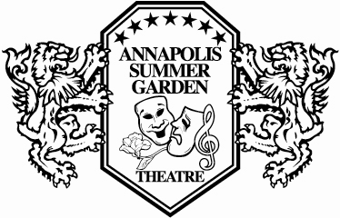
Annapolis Summer Garden Theatre
DIRECTOR QUESTIONAIRE for the 2021 Season

ASGT is a community theatre led by volunteers. ASGT’s outdoor performance space in downtown Annapolis offers unique opportunities and challenges for directors. Kindly keep this in mind as you answer the questions below.

Please submit your completed questionnaire (and resumé) to production@summergarden.com at your earliest convenience. Thank you for your interest!

Show you are interested in directing: “Bright Star”

Name:
Address:
Phone:
Email:

Please describe your directing experience (100 words max. or attach resumé):

Please describe your experience with outdoor theatre, if any (50 words max.):

Please describe your vision for the show. Although some set design, sound design and costume design work has been started that we will likely want to utilize, please include thoughts on those as well (400 words max.):

Please describe any specific challenges with this show?? Example: Casting, set, costumes, etc.?

Please provide the names, and phone/e-mails for three references that are familiar with your
directing experience or theatrical credentials.

NAME PHONE NUMBER or E-MAIL

REFERENCE #1 _________________________ ____________________________

REFERENCE #2 _________________________ ____________________________

REFERENCE #3 _________________________ ____________________________

